**Fresh concerns raised over cannabis and anxiety despite positive reports from patients**

Questions have again been raised over the role of medicinal cannabis in treating mental health and sleep disorders despite a patient study showing almost unanimous faith in its efficacy.

All but 3% of 3,323 participants in the Cannabis as a Medicine Survey 2022 (CAMS22) reported improvements in their health, irrespective of indication, with only a handful suggesting their condition worsened.

The CAMS22 research received 3,323 responses, more than double the previous online survey

The anonymous online study is the fourth – and by far the largest – instalment of the CAMS project which is funded by the Lambert Initiative and designed to unlock trends in the medicinal cannabis landscape.

The number of respondents was more than double the previous survey.

Of those who completed the questionnaire between December 2022 and April 2023, nearly three quarters had been prescribed cannabis through a medical practitioner, with 27% sourcing it illicitly. In the [previous 2020 study](https://www.cannabiz.com.au/patients-using-illicit-medicinal-cannabis-are-more-likely-to-be-younger-and-male/), only a third had sourced products legally.

While revealing many harm-reduction benefits, the findings raised [fresh concerns that prescribers are treating anxiety](https://www.cannabiz.com.au/flower-prescriptions-for-anxiety-growing-despite-lack-of-evidence-according-to-new-lambert-study/) and sleep disorders with medicinal cannabis where there is little evidence of efficacy.

Self-medicators, or illicit users, listed mental health as the main condition they are treating (40%), followed by pain (33%) and sleep disorders (13%). Among prescription holders, pain was the principal condition (38%), followed by mental health (34%) and sleep (16%).

Researchers said the data illustrates a “worrying willingness” among Australian doctors to prescribe cannabis “for which there is little evidence of efficacy”.

“There is a reasonable body of evidence to support effectiveness for pain conditions, but we still have a long way to go when it comes to understanding the impact of cannabis on conditions such as anxiety or depression,” said Dr Llew Mills, from Sydney University’s Specialty of Addiction Medicine and lead researcher on the CAMS project.

Expanding on the issue, he told *Cannabiz*: “A culture has emerged where it seems to be okay to prescribe cannabis for anxiety. I strongly suspect it’s come from the entry of commercial players into the market.

“They are often working in-house for clinics and the way they make money is by registering clients and prescribing cannabis. There is less incentive to do the kind of thorough breakdown of a patient’s history.

“It’s not dissimilar to the model that existed in California before it was legalised for recreational use where you basically had a recreational, or non-medical, market operating under the guise of a medical market where it was easy to get a prescription for whatever the hell you wanted.

“That said, there are probably people out there who are legitimately suffering from anxiety and being prescribed medicinal cannabis, and that’s a worry.”

Mills described the body of evidence for pain as “not too bad, but not amazing”, with studies showing that it works “but not in the traditional way that non-steroidal anti-inflammatories do”.

“That’s the problem with pain literature. Researchers don’t really know how it’s working,” he said. “For mental health and sleep there is not a lot of evidence at all. That’s not to say it can’t help some people and that evidence may emerge. It’s just understudied so it’s probably wise to err on the side of caution and not prescribe it for something where there is little evidence.”

Despite the absence of trial data, nearly all respondents claimed they were experiencing the benefits of cannabis.

Asked to explain that conflict Mills said it was “complex”, suggesting patients may mistakenly believe that cannabis is treating their condition.

“Some believe it’s treating their anxiety because when they stop, they feel anxious. Anxiety is a withdrawal symptom from all drugs,” he said. “It may not be that cannabis is treating their anxiety, it may be that the absence of cannabis is causing their anxiety.”

The research paper, published in [Harm Reduction Journal](https://harmreductionjournal.biomedcentral.com/articles/10.1186/s12954-024-00992-1), suggested that regulators “must consider the level of autonomy they wish to allow clinicians”, noting how some jurisdictions limit the range of conditions for which cannabis can be prescribed.

The regulatory framework in Australia “leaves this to the discretion of the clinician and patient”, it said.

Mills stressed the report’s authors, which include the Lambert Initiative’s Iain McGregor and Jonathon Arnold and addiction specialist Nicholas Lintzeris, were not advocating for regulatory change in Australia, and were simply “scientists reporting our findings and helping people interpret them”.

“Some people think that would be overkill [to limit the range of conditions],” he observed. “Personally I think they should decriminalise non-medical cannabis. That would clean up this whole space.”

Regardless of its efficacy, the study revealed a number of harm-reduction benefits for those consuming prescribed cannabis.

Among illicit users, 65% smoked their cannabis, while 23% did not know the composition of what they were using. That fell to 22% and 1% respectively among prescription holders.

Furthermore, those with medical-grade products reported significantly fewer side effects, with the odds of reporting any given side-effect an estimated 7.1 times lower than illicit users.

Across both cohorts, while dry mouth, increased appetite, drowsiness, eye irritation and memory problems were noted as issues, they were nearly always “mild and tolerable”.

Mills said: “From a harm-reduction perspective, the increase in prescribed use [from previous studies] is very positive because it means people are getting exposure to the medical system and getting guidance from doctors, even though that might vary a little.

“Prescribed users report fewer side effects, they are more certain of the content, and they tend not to smoke it as much.”

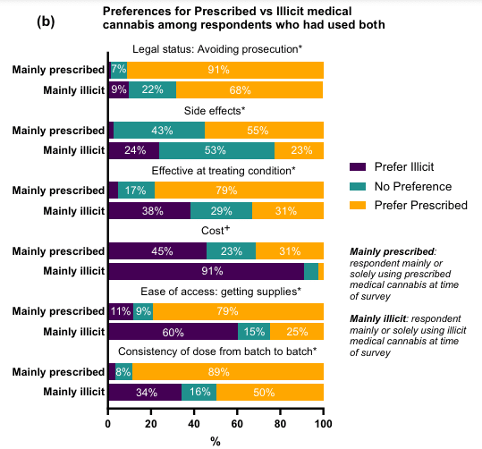

Respondents who had used both legal and illicit cannabis over the past 12 months – 1,589 out of the 3,323 total – were also asked which pathway they preferred.

Of those who “mainly” used prescribed medication during that period, the vast majority said they preferred it to illicit use on all but one measure – price.

Yet excluding those who did not pay for their prescribed medicine, the study showed prescribed users actually paid an average of A$10.40 less per week than those who bought from a dealer.

The study also highlighted the importance to the market of specialist clinics.

Of those with legally prescribed cannabis, 80% obtained their medication from a clinic and only 20% from a regular GP.

More data from CAMS22 on consumer attitudes to clinics is expected to be released in a separate paper.